

OOP IY4101

Practical Programming Assignment 2: OOP – Shape Management Application

Cohort: January 2026
Student ID: 303066791
Student Name: Chun Yin Yip
Tutor: Dr.Dena S.Y.Nuuman
Word count: 880
Table of Contents
Introduction 2
User Requirements 3
UML Class Diagram 4
Implementation 5
Testing and Results 6
Problems Encountered and Solutions 7
Conclusion 8
References 9
Appendix A: Source Code 10
Appendix B: Testing Picture 11

Introduction

Objective and Purpose
- Assignment Objective:
This assignment objective is we need to design and build some classes for geometrical shapes. We need to use Object-Oriented Programming (OOP) concepts like inheritance and polymorphism to do this.
- Purpose of the Application:
The purpose of the application is it can help users to manage different shapes. Users can calculate the area and perimeter easily. Also, they can move the positions and change the size of the shapes.

Methodology
- Development Approach:
First, we draw a UML class diagram to plan the structure of the classes. After that, we write the code step by step using inheritance. Finally, we test the program to make sure it has no errors.
- Programming Language:
We use Java to write this program. Java is a good object-oriented language and it is easy to use.

Structure of the Assignment
- Outline of Sections:
First, this report will show the user requirements. Second, it will show the UML diagram. Next, it will explain the implementation and the testing results. Lastly, you can learn about the problems we encountered and the conclusion.

User Requirements
Functional Requirements:
The application must have a console menu for users. Users can add shapes like circle, square, rectangle and triangle. Users can remove shapes by position. Also, users can get the area and perimeter of the shapes by position. Moreover, users can translate all shapes and scale all shapes. The program needs to use integer division when scaling the shapes.
Non-Functional Requirements:
- Performance:
The program needs to run fast and calculate the area and perimeter correctly.
- Usability:
The menu needs to be clear and easy for users to read. If users input wrong things, the program will tell them to input again.
- Security:
The program does not need high security because it is just a simple console application and it does not save personal data.
- Reliability and Availability:
The program should be stable. It can handle errors like inputting the wrong position without crashing.

UML Class Diagram
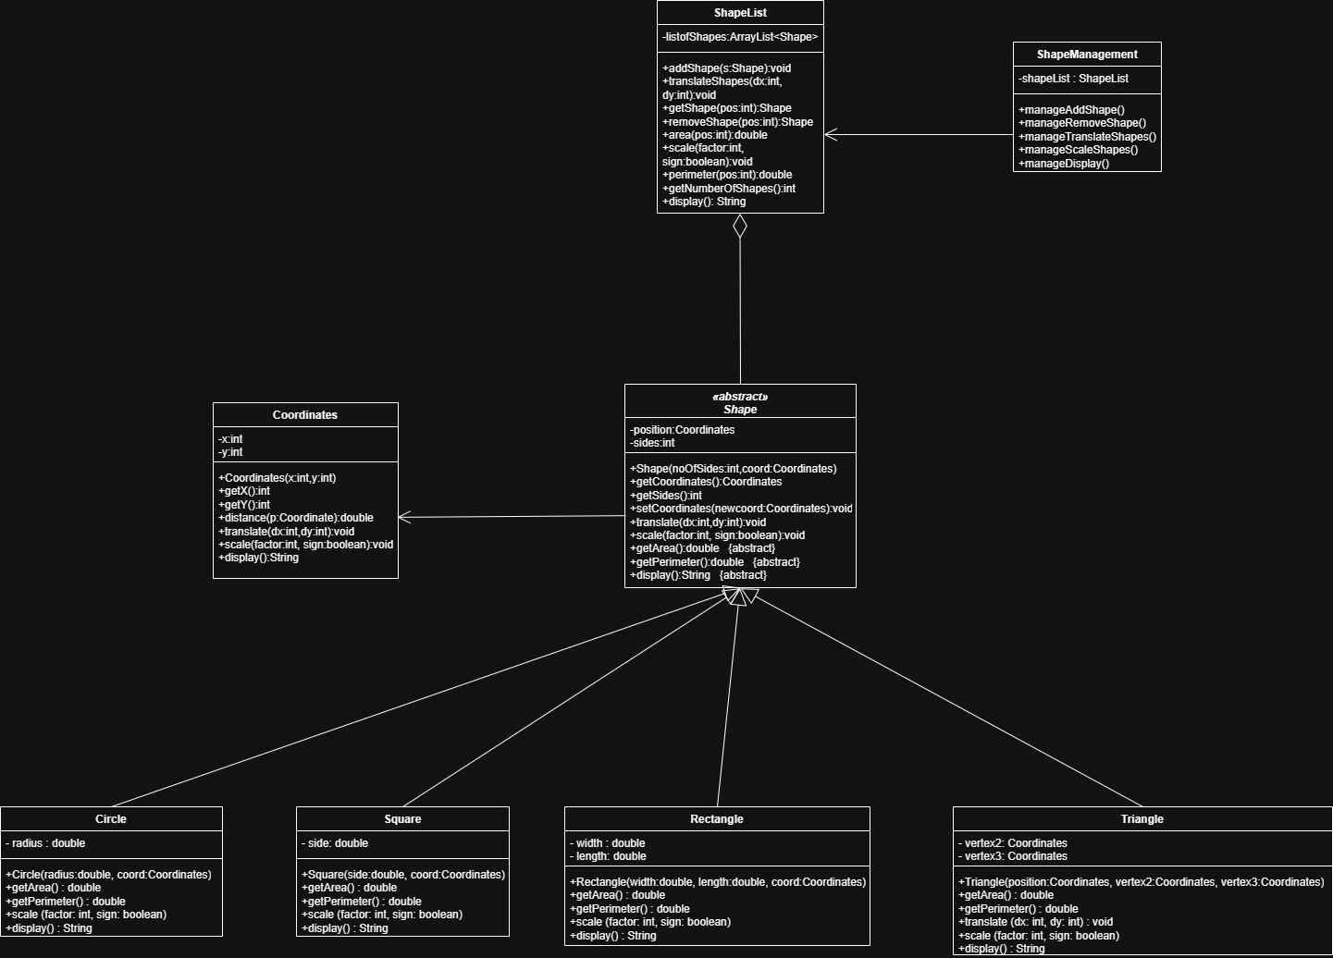

Implementation
In this project, I created a Shape class as an abstract class. It has position and sides. Then, I created four subclasses, they are Rectangle, Square, Circle and Triangle. They inherit the Shape class and override some methods. For example, Triangle overrides the translate and scale methods because it has three vertices.
Also, I created a ShapeList class. It uses ArrayList to store the shapes. Lastly, I created a ShapeManagement class. It has a switch case menu to let users choose what to do. I also added try-catch to prevent the program from crashing when users input wrong things.
This project demonstrates the four main Object-Oriented Programming principles.
Encapsulation was achieved by declaring attributes such as x, y, position, and radius as private and providing public methods to access or modify them.
Inheritance was implemented by allowing Rectangle, Square, Circle, and Triangle to extend the abstract Shape class and reuse common methods.
Polymorphism was used in the ShapeList class, where different subclasses are stored in an ArrayList<Shape>. Methods such as display(), getArea(), and translate() are called through the Shape reference, and Java automatically executes the correct overridden method.
Abstraction was achieved by defining Shape as an abstract class with abstract methods such as getArea(), getPerimeter(), and display(), which are implemented differently by each subclass.

Testing and Results
Action | Expected result | Actual result
Create a triangle (60,60), (30,80), (80,80) and add it | Program says "Triangle added." | Program says "Triangle added."
Create a rectangle pos (110,30) width 20 length 25 and add it | Program says "Rectangle added." | Program says "Rectangle added."
Create a circle pos (90,110) radius 35 and add it | Program says "Circle added." | Program says "Circle added."
Create a square pos (100,50) side 30 and add it | Program says "Square added." | Program says "Square added."
Show area and perimeter of the second shape (Rectangle). (Enter 2) | Area: 500.0, Perimeter: 90.0 | Area: 500.0, Perimeter: 90.0
Display information of all shapes | Shows 4 shapes with details | Shows 4 shapes with details
Remove the third shape (Circle) (Enter 3) | Shape removed successfully | Shape removed successfully
Display information of all shapes | Shows Circle have been removed | Shows Circle have been removed
Translate all shapes by 20 for x and 25 for y | All shapes' coordinates increase | All shapes' coordinates increase
Display information of all shapes | Shows updated positions | Shows updated positions
Increase all shapes by factor of 5 | All sizes multiply by 5 | All sizes multiply by 5
Display all shapes and see if changed | Shows updated sizes | Shows updated sizes
Error handling: remove shape at pos 30 | Show error message, no crash | Show error message, no crash
Error handling: input wrong text in menu | Says "Invalid input", no crash | Says "Invalid input", no crash
Terminal output screenshot at Appendix B: Testing Picture section.

Problems Encountered and Solutions
During the programming, I encountered some problems. First, the assignment requires the scale method to use integer division. At first, I used double for the radius and width, so the division result had decimals. For example, 7 divided by 2 became 3.5. But the assignment wants it to become 3. Therefore, I solved this problem by adding an "(int)" to cast the result. It forces the double to become an integer, so 3.5 becomes 3.
Another problem was about the user input. When I test the program, if I input some letters like "abc" instead of numbers, the program will crash and show "NumberFormatException". This is a terrible problem. Therefore, I wrote some helper methods like "readInt" and "readDouble". Inside these methods, I used "try-catch" and a while loop. If the user inputs wrong things, it will catch the error and ask the user to input again. This solved the crashing problem.

Conclusion
In conclusion, this assignment is very useful for learning Object-Oriented Programming. I successfully designed the classes using UML and wrote the Java code. I learned how to use inheritance, polymorphism and ArrayList. Also, I learned how to handle errors using try-catch to make the program more reliable. The program works perfectly and meets all the user requirements. Therefore, this project is a big success.

Appendix A: Source Code

Circle.java :

public class Circle extends Shape {
private double radius;

// Constructor: creates a Circle with the given radius and position
public Circle(double radius, Coordinates coord) {
super(0, coord);
this.radius = radius;
}

// Scales the circle's radius and position by multiplying (sign=true) or dividing (sign=false) by factor
@Override
public void scale(int factor, boolean sign) {
super.scale(factor, sign);
if (sign) {
this.radius *= factor;
} else {
if (factor != 0) {
this.radius = (int) (this.radius / factor);
}
}
}

// Returns the area of the circle using the formula PI * r * r
@Override
public double getArea() {
return Math.PI * radius * radius;
}

// Returns the perimeter (circumference) of the circle using the formula 2 * PI * r
@Override
public double getPerimeter() {
return 2 * Math.PI * radius;
}

// Returns a string with all information about this circle
@Override
public String display() {
return "Shape: Circle, Sides: " + getSides() + ", Position: (" + getCoordinates().display() +
"), Radius: " + radius + ", Area: " + getArea() + ", Perimeter: " + getPerimeter();
}
}

Coordinates.java :

public class Coordinates {
private int x;
private int y;

// Constructor: creates a Coordinates object with the given x and y values
public Coordinates(int x, int y) {
this.x = x;
this.y = y;
}

// Returns the x value of this coordinate
public int getX() {
return x;
}

// Returns the y value of this coordinate
public int getY() {
return y;
}

// Calculates and returns the distance between this point and another point p
public double distance(Coordinates p) {
double diffX = p.getX() - this.x;
double diffY = p.getY() - this.y;
return Math.sqrt((diffX * diffX) + (diffY * diffY));
}

// Moves this coordinate by adding dx to x and dy to y
public void translate(int dx, int dy) {
this.x += dx;
this.y += dy;
}

// Scales this coordinate by multiplying (sign=true) or dividing (sign=false) by factor
public void scale(int factor, boolean sign) {
if (sign) {
this.x *= factor;
this.y *= factor;
} else {
if (factor != 0) {
this.x /= factor;
this.y /= factor;
}
}
}

// Returns a string showing the x and y values
public String display() {
return "X = " + x + ", Y = " + y;
}
}

Rectangle.java :

public class Rectangle extends Shape {
private double width;
private double length;

// Constructor: creates a Rectangle with the given width, length and position
public Rectangle(double width, double length, Coordinates coord) {
super(4, coord);
this.width = width;
this.length = length;
}

// Scales the rectangle's width, length and position by multiplying (sign=true) or dividing (sign=false) by factor
// Uses integer division when dividing to truncate the result (e.g. 7 / 2 = 3)
@Override
public void scale(int factor, boolean sign) {
super.scale(factor, sign);
if (sign) {
this.width *= factor;
this.length *= factor;
} else {
if (factor != 0) {
this.width = (int) (this.width / factor);
this.length = (int) (this.length / factor);
}
}
}

// Returns the area of the rectangle using the formula width * length
@Override
public double getArea() {
return width * length;
}

// Returns the perimeter of the rectangle using the formula 2 * width + 2 * length
@Override
public double getPerimeter() {
return 2 * width + 2 * length;
}

// Returns a string with all information about this rectangle
@Override
public String display() {
return "Shape: Rectangle, Sides: " + getSides() + ", Position: (" + getCoordinates().display() +
"), Width: " + width + ", Length: " + length + ", Area: " + getArea() + ", Perimeter: "
+ getPerimeter();
}
}

Shape.java :

public abstract class Shape {
private Coordinates position;
private int sides;

// Constructor: sets the number of sides and the starting position of the shape
public Shape(int noOfSides, Coordinates coord) {
this.sides = noOfSides;
this.position = coord;
}

// Returns the position (coordinates) of this shape
public Coordinates getCoordinates() {
return position;
}

// Returns the number of sides of this shape
public int getSides() {
return sides;
}

// Updates the position of this shape to a new coordinate
public void setCoordinates(Coordinates newcoord) {
this.position = newcoord;
}

// Moves the shape's position by dx and dy
public void translate(int dx, int dy) {
position.translate(dx, dy);
}

// Scales the shape's position by multiplying or dividing by factor
public void scale(int factor, boolean sign) {
position.scale(factor, sign);
}

// Returns the area of this shape (to be implemented by subclasses)
public abstract double getArea();

// Returns the perimeter of this shape (to be implemented by subclasses)
public abstract double getPerimeter();

// Returns a string with all information about this shape (to be implemented by subclasses)
public abstract String display();
}

ShapeList.java :

import java.util.ArrayList;

public class ShapeList {
private ArrayList<Shape> listOfShapes;

// Constructor: creates an empty list to store shapes
public ShapeList() {
this.listOfShapes = new ArrayList<>();
}

// Adds a shape to the end of the list
public void addShape(Shape s) {
listOfShapes.add(s);
}

// Moves all shapes in the list by dx and dy
public void translateShapes(int dx, int dy) {
for (Shape s : listOfShapes) {
s.translate(dx, dy);
}
}

// Returns the shape at the given position, or null if the position does not exist
public Shape getShape(int pos) {
if (pos >= 0 && pos < listOfShapes.size()) {
return listOfShapes.get(pos);
}
System.out.println("Error: No shape at position " + pos);
return null;
}

// Removes and returns the shape at the given position, or null if the position does not exist
public Shape removeShape(int pos) {
if (pos >= 0 && pos < listOfShapes.size()) {
return listOfShapes.remove(pos);
}
System.out.println("Error: Cannot remove, no shape at position " + pos);
return null;
}

// Returns the area of the shape at the given position, or -1 if not found
public double area(int pos) {
Shape s = getShape(pos);
if (s != null) {
return s.getArea();
}
return -1;
}

// Scales all shapes in the list by multiplying (sign=true) or dividing (sign=false) by factor
public void scale(int factor, boolean sign) {
for (Shape s : listOfShapes) {
s.scale(factor, sign);
}
}

// Returns the perimeter of the shape at the given position, or -1 if not found
public double perimeter(int pos) {
Shape s = getShape(pos);
if (s != null) {
return s.getPerimeter();
}
return -1;
}

// Returns the total number of shapes currently in the list
public int getNumberOfShapes() {
return listOfShapes.size();
}

// Returns a string showing all shapes in the list with their details
public String display() {
StringBuilder sb = new StringBuilder();
sb.append("ShapeList contains ").append(getNumberOfShapes()).append(" shapes:\n");
for (int i = 0; i < listOfShapes.size(); i++) {
sb.append("[").append(i + 1).append("] ").append(listOfShapes.get(i).display()).append("\n");
}
return sb.toString();
}
}

ShapeManagement.java :

import java.util.Scanner;

public class ShapeManagement {
private ShapeList shapeList;
private Scanner scanner;

// Constructor: creates a new ShapeList and Scanner for user input
public ShapeManagement() {
this.shapeList = new ShapeList();
this.scanner = new Scanner(System.in);
}

// Reads and returns a valid integer from the user, keeps asking if input is invalid
private int readInt(String prompt) {
while (true) {
System.out.print(prompt);
try {
return Integer.parseInt(scanner.nextLine());
} catch (NumberFormatException e) {
System.out.println("Invalid input. Please enter a valid integer.");
}
}
}

// Reads and returns a valid decimal number from the user, keeps asking if input is invalid
private double readDouble(String prompt) {
while (true) {
System.out.print(prompt);
try {
return Double.parseDouble(scanner.nextLine());
} catch (NumberFormatException e) {
System.out.println("Invalid input. Please enter a valid number.");
}
}
}

// Reads and returns a valid boolean (true/false) from the user, keeps asking if input is invalid
private boolean readBoolean(String prompt) {
while (true) {
System.out.print(prompt);
String input = scanner.nextLine().trim().toLowerCase();
if (input.equals("true") || input.equals("false")) {
return Boolean.parseBoolean(input);
}
System.out.println("Invalid input. Please enter 'true' or 'false'.");
}
}

// Runs the main menu loop until the user chooses to quit
public void run() {
boolean running = true;
while (running) {
System.out.println("\n--- Shape Management Menu ---");
System.out.println("1: Add a shape");
System.out.println("2: Remove a shape by position");
System.out.println("3: Get information about a shape by position");
System.out.println("4: Area and perimeter of a shape by position");
System.out.println("5: Display information of all the shapes");
System.out.println("6: Translate all the shapes");
System.out.println("7: Scale all the shapes");
System.out.println("0: Quit program");

int choice = readInt("Enter your choice: ");

switch (choice) {
case 1:
manageAddShape();
break;
case 2:
manageRemoveShape();
break;
case 3:
manageShapeInfo();
break;
case 4:
manageAreaAndPerimeter();
break;
case 5:
manageDisplay();
break;
case 6:
manageTranslateShapes();
break;
case 7:
manageScaleShapes();
break;
case 0:
running = false;
System.out.println("Exiting program. Goodbye!");
break;
default:
System.out.println("Invalid choice. Please select from the menu.");
break;
}
}
}

// Asks the user to select a shape type, then reads its details and adds it to the list
private void manageAddShape() {
System.out.println("Select shape to add: ");
System.out.println("1: Rectangle");
System.out.println("2: Square");
System.out.println("3: Circle");
System.out.println("4: Triangle");
int type = readInt("> ");
int x = readInt("Enter X coordinate: ");
int y = readInt("Enter Y coordinate: ");
Coordinates coord = new Coordinates(x, y);

switch (type) {
case 1:
double w = readDouble("Enter width: ");
double l = readDouble("Enter length: ");
shapeList.addShape(new Rectangle(w, l, coord));
System.out.println("Rectangle added.");
break;
case 2:
double s = readDouble("Enter side: ");
shapeList.addShape(new Square(s, coord));
System.out.println("Square added.");
break;
case 3:
double r = readDouble("Enter radius: ");
shapeList.addShape(new Circle(r, coord));
System.out.println("Circle added.");
break;
case 4:
int x2 = readInt("Enter V2 X coordinate: ");
int y2 = readInt("Enter V2 Y coordinate: ");
int x3 = readInt("Enter V3 X coordinate: ");
int y3 = readInt("Enter V3 Y coordinate: ");
shapeList.addShape(new Triangle(coord, new Coordinates(x2, y2), new Coordinates(x3, y3)));
System.out.println("Triangle added.");
break;
default:
System.out.println("Invalid shape type.");
break;
}
}

// Asks the user for a position and removes the shape at that position
private void manageRemoveShape() {
int pos = readInt("Enter position to remove (1, 2, 3...): ");
Shape removed = shapeList.removeShape(pos - 1);
if (removed != null) {
System.out.println("Shape removed successfully.");
}
}

// Asks the user for a position and displays the information of the shape at that position
private void manageShapeInfo() {
int pos = readInt("Enter position to view info (1, 2, 3...): ");
Shape shape = shapeList.getShape(pos - 1);
if (shape != null) {
System.out.println(shape.display());
}
}

// Asks the user for a position and displays the area and perimeter of the shape at that position
private void manageAreaAndPerimeter() {
int pos = readInt("Enter position (1, 2, 3...): ");
Shape shape = shapeList.getShape(pos - 1);
if (shape != null) {
System.out.println("Area: " + shapeList.area(pos - 1));
System.out.println("Perimeter: " + shapeList.perimeter(pos - 1));
}
}

// Displays all shapes currently in the list
private void manageDisplay() {
System.out.println(shapeList.display());
}

// Asks the user for dx and dy values, then translates all shapes
private void manageTranslateShapes() {
int dx = readInt("Enter X distance (dx): ");
int dy = readInt("Enter Y distance (dy): ");
shapeList.translateShapes(dx, dy);
System.out.println("All shapes translated by dx=" + dx + ", dy=" + dy);
}

// Asks the user for a scale factor and direction, then scales all shapes
private void manageScaleShapes() {
int factor = readInt("Enter factor: ");
boolean sign = readBoolean("Multiply (true) or Divide (false)? ");
shapeList.scale(factor, sign);
System.out.println("All shapes scaled by factor=" + factor + ", sign=" + sign);
}

// Entry point of the program
public static void main(String[] args) {
ShapeManagement app = new ShapeManagement();
app.run();
}
}

Square.java :

public class Square extends Shape {
private double side;

// Constructor: creates a Square with the given side length and position
public Square(double side, Coordinates coord) {
super(4, coord);
this.side = side;
}

// Scales the square's side and position by multiplying (sign=true) or dividing (sign=false) by factor
// Uses integer division when dividing to truncate the result (e.g. 7 / 2 = 3)
@Override
public void scale(int factor, boolean sign) {
super.scale(factor, sign);
if (sign) {
this.side *= factor;
} else {
if (factor != 0) {
this.side = (int) (this.side / factor);
}
}
}

// Returns the area of the square using the formula side * side
@Override
public double getArea() {
return side * side;
}

// Returns the perimeter of the square using the formula 4 * side
@Override
public double getPerimeter() {
return 4 * side;
}

// Returns a string with all information about this square
@Override
public String display() {
return "Shape: Square, Sides: " + getSides() + ", Position: (" + getCoordinates().display() +
"), Side: " + side + ", Area: " + getArea() + ", Perimeter: " + getPerimeter();
}
}

Triangle.java :

public class Triangle extends Shape {
private Coordinates vertex2;
private Coordinates vertex3;

// Constructor: creates a Triangle with three vertices (position is vertex1)
public Triangle(Coordinates position, Coordinates vertex2, Coordinates vertex3) {
super(3, position);
this.vertex2 = vertex2;
this.vertex3 = vertex3;
}

// Moves all three vertices of the triangle by dx and dy
@Override
public void translate(int dx, int dy) {
super.translate(dx, dy);
vertex2.translate(dx, dy);
vertex3.translate(dx, dy);
}

// Scales all three vertices of the triangle by multiplying (sign=true) or dividing (sign=false) by factor
@Override
public void scale(int factor, boolean sign) {
super.scale(factor, sign);
vertex2.scale(factor, sign);
vertex3.scale(factor, sign);
}

// Returns the area of the triangle using Heron's Formula
@Override
public double getArea() {
double a = getCoordinates().distance(vertex2);
double b = vertex2.distance(vertex3);
double c = vertex3.distance(getCoordinates());
double s = (a + b + c) / 2.0;
return Math.sqrt(s * (s - a) * (s - b) * (s - c));
}

// Returns the perimeter of the triangle as the sum of the three side lengths
@Override
public double getPerimeter() {
double a = getCoordinates().distance(vertex2);
double b = vertex2.distance(vertex3);
double c = vertex3.distance(getCoordinates());
return a + b + c;
}

// Returns a string with all information about this triangle
@Override
public String display() {
return "Shape: Triangle, Sides: " + getSides() + ", Vertices: V1(" + getCoordinates().display() +
"), V2(" + vertex2.display() + "), V3(" + vertex3.display() + "), Area: " + getArea() +
", Perimeter: " + getPerimeter();
}
}

Appendix B: Testing Picture
If the picture is not clear, you can check Terminal output.png
